Regarding Salvation
Pastor Yoo Nam Kang
John 3:16

John 3:16
“For God loved the world so much that he gave his one and only Son, so that everyone who believes in him will not perish but have eternal life.
Salvation of the Spirit: Present Event
Ephesians 2:8
God saved you by his grace when you believed. And you can’t take credit for this; it is a gift from God.
Salvation of the Soul: Present Event
Philippians 2:12
Dear friends, you always followed my instructions when I was with you. And now that I am away, it is even more important. Work hard to show the results of your salvation, obeying God with deep reverence and fear.
Salvation of the Body: Future Event
2Timothy 4:18
Yes, and the Lord will deliver me from every evil attack and will bring me safely into his heavenly Kingdom. All glory to God forever and ever! Amen.

- Let Us Receive Eternal Life
John 3:16
“For God loved the world so much that he gave his one and only Son, so that everyone who believes in him will not perish but have eternal life.
1Peter 1:3-4
3 All praise to God, the Father of our Lord Jesus Christ. It is by his great mercy that we have been born again, because God raised Jesus Christ from the dead. Now we live with great expectation, 4 and we have a priceless inheritance—an inheritance that is kept in heaven for you, pure and undefiled, beyond the reach of change and decay.
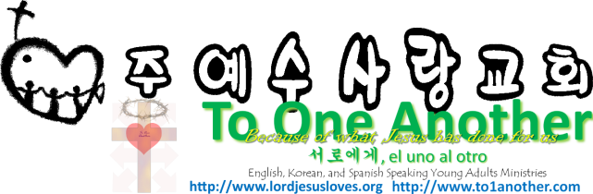
- Let Us Live a Life of the New Covenant
Ezekiel 36:26-27
26 And I will give you a new heart, and I will put a new spirit in you. I will take out your stony, stubborn heart and give you a tender, responsive heart. 27 And I will put my Spirit in you so that you will follow my decrees and be careful to obey my regulations.
1John 4:10-11, 18
10 This is real love—not that we loved God, but that he loved us and sent his Son as a sacrifice to take away our sins. 11 Dear friends, since God loved us that much, we surely ought to love each other. 18 Such love has no fear, because perfect love expels all fear. If we are afraid, it is for fear of punishment, and this shows that we have not fully experienced his perfect love.
John 14:21
Those who accept my commandments and obey them are the ones who love me. And because they love me, my Father will love them. And I will love them and reveal myself to each of them.”
1John 3:22
And we will receive from him whatever we ask because we obey him and do the things that please him.
Ephesians 5:25, 28
25 For husbands, this means love your wives, just as Christ loved the church. He gave up his life for her 28 In the same way, husbands ought to love their wives as they love their own bodies. For a man who loves his wife actually shows love for himself.
- Let Us Live in the Light
1John 1:7
But if we are living in the light, as God is in the light, then we have fellowship with each other, and the blood of Jesus, his Son, cleanses us from all sin.
Romans 8:16
For his Spirit joins with our spirit to affirm that we are God’s children.
1John 4:7-8
7 Dear friends, let us continue to love one another, for love comes from God. Anyone who loves is a child of God and knows God. 8 But anyone who does not love does not know God, for God is love.
1John 2:9-10
9 If anyone claims, “I am living in the light,” but hates a Christian brother or sister, that person is still living in darkness. 10 Anyone who loves another brother or sister is living in the light and does not cause others to stumble.

